# **Week 2: Business Modelling**

[8.9.2021 - 13.9.2021]

[Add presenter here]

[Add topic here]

**Week 2: Business Modelling** **1**

Notes: Lesson 1 1

Business Model Notions 3

Business model perspectives 3

Business models in context - viewpoints 3

The Rea Ontology 4

Commitments and contracts 8

What economic agents are there? 12

What economic resources are there? 12

What economic events are there? 13

What economic commitments and contracts are there? 14

VDML - value delivery modelling language 15

## **Notes: Lesson 1**

Business model overview

* Purpose, use and architecture of business models

Why business models?

* To articulate, communicate and develop vague business ideas
  + We want to distribute our music electronically
  + We want to outsource our ICT support
  + We want to form a joint venture with a movie-making company

Why **ARTICULATE**  business ideas?

* Innovate the business
  + Identify new biz opportunities
* For Common understanding
  + Different stakeholders can work together
* For analysis and evaluation
  + so risks and opportunities can be assessed
* For ICT development
  + So effective and efficient systems can be designed

What does a business model answer?

* Which is our value proposition?
* How does our company create and market this value?
* Which actors are needed to offer the value?
* What value do the actors offer each other?

…

| Business models vs. Process models | Business model | Process model |
| --- | --- | --- |
| Focus what it identifies agents, resources, and exchanges of resources between agents | Process model focuses on the how- it deals with operation and procedural aspects of business communication |
|
|
|
|

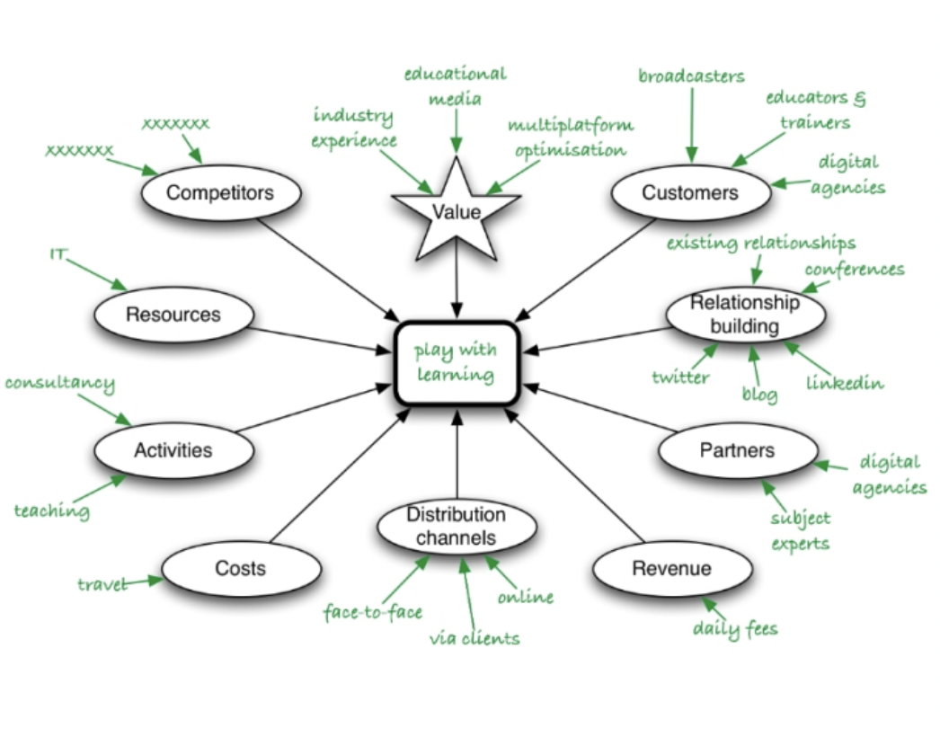

## Business Model Notions

* Actor
* Supplier
* Customer
* Resource
* Value object
* Value proposition
* Value transfer
* Value exchange
* Value port
* Economic event
* Duality
* Reciprocity
* Compensation
* Contract
* Distribution channel
* Value chain
* Capability
* Trust
* Customer relationship

## Business model perspectives

* Internal perspective
  + Looking from within an organisation
* External perspective
  + Looking at a web of organisations

## Business models in context - viewpoints

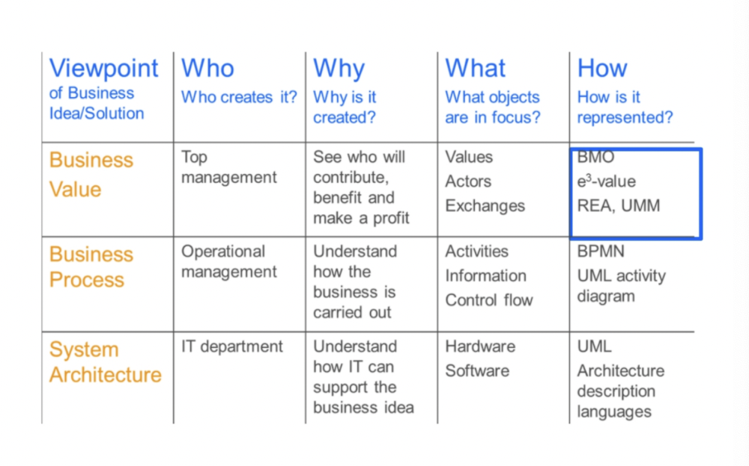

## The Rea Ontology

R = economic resources

E = economic event (duality )

A = economic agent

An example of an exchange

## 

## 

## 

**Economic resources**

* An economic resource is something of value that is under the control of an agent and that can be transferred from one agent to another
* Examples: cash, goods, labour service

**Non-economic resources**

* Some resources cannot be traded
* An internal resource is a resource that is dependent on one agent. It cannot be traded independently of the agent
* Examples: knowledge, beauty, skills

**Non-economic resources**

* Some resources cannot be traded
* An **internal resource** is a resource that is dependent on one agent, it cannot be traded independently of the agent
* Examples knowledge, beauty, skills
* A **shared resource** is a relationship, dependent on two or more agents
* Examples, marriage, citizenship

**Economic Events**

* An economic event is the transfer of control of an economic resource from one agent to another agent
* Examples: cash-payment, shipment

**Economic agents**

* An economic agent is someone who is able to participate in economic events
* Examples: IBM, John Doe, City of Stockholm
* Examples of agent roles, manufacturer, distributor, carrier, consumer

## 

**Duality**

* Duality is a relationship between economic events expressing that in order to obtain an economic resource, an agent must give up another economic resource.
* “One good turn deserves another”

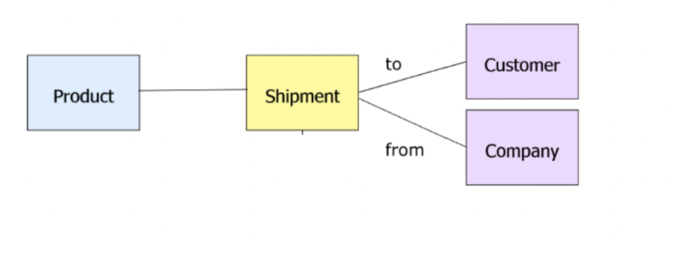

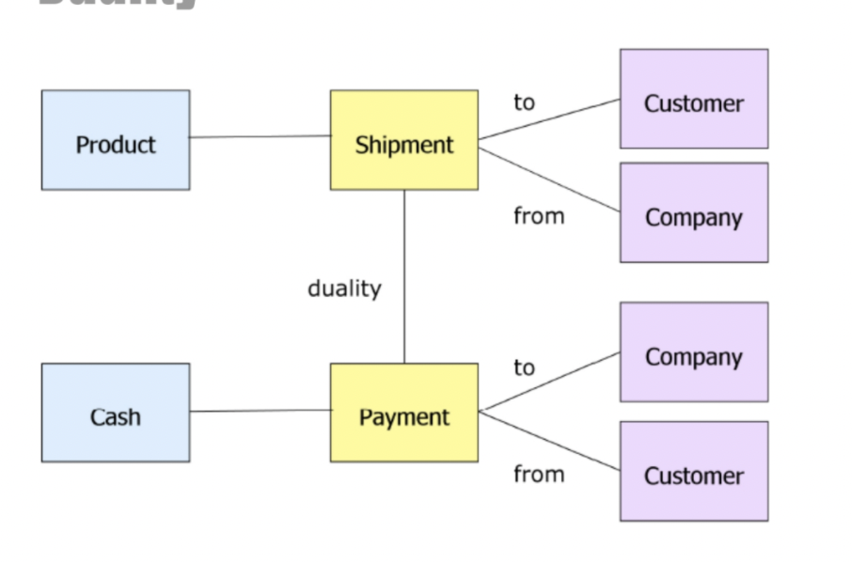

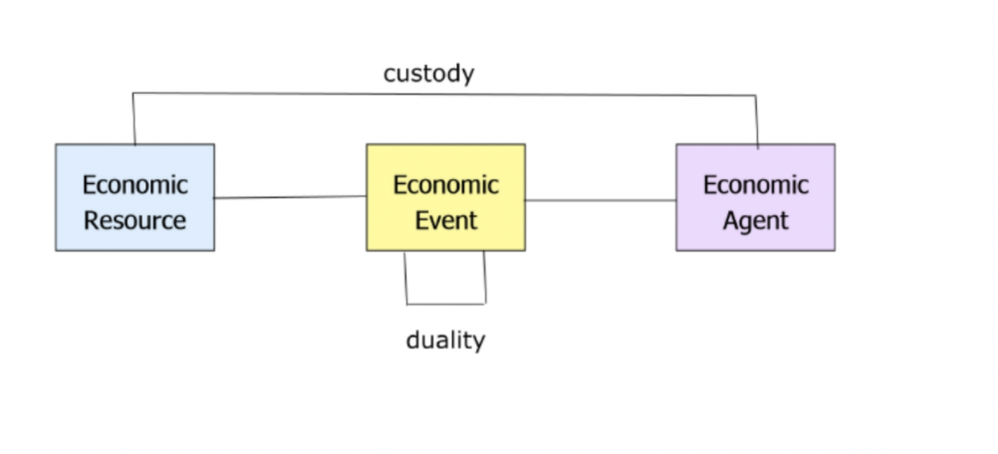

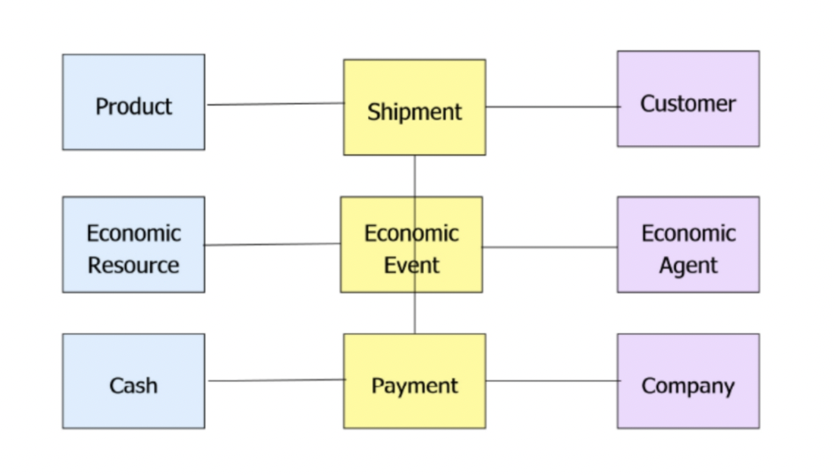

#### **Commitments and contracts**

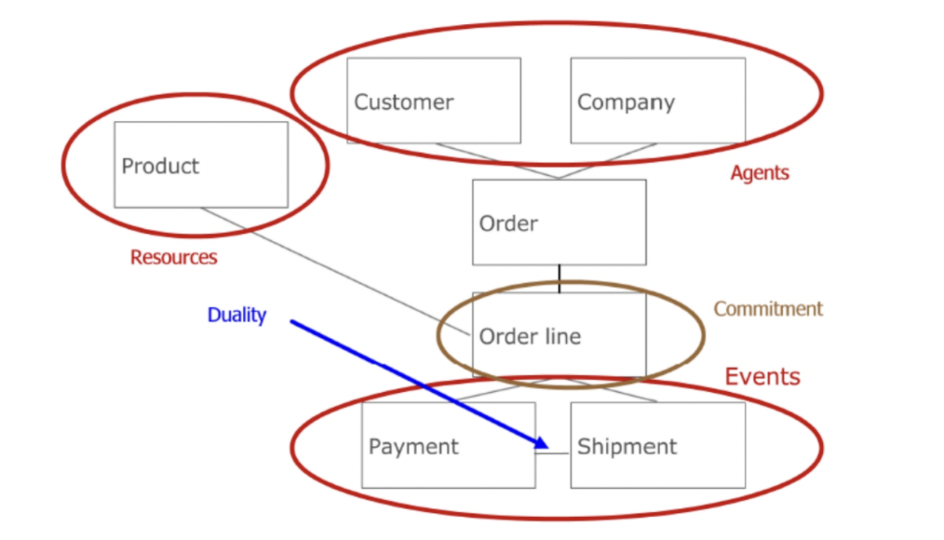

**Economic commitments**

* An economic commitment is an obligation to perform an economic event in the future
* Example: order lines
* An economic contract is a container for a collection of economic commitments
* Example: purchase order with several line items

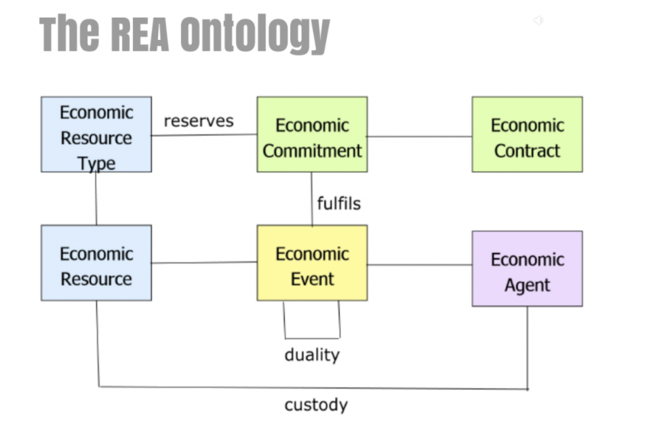

**Operational level and knowledge level**

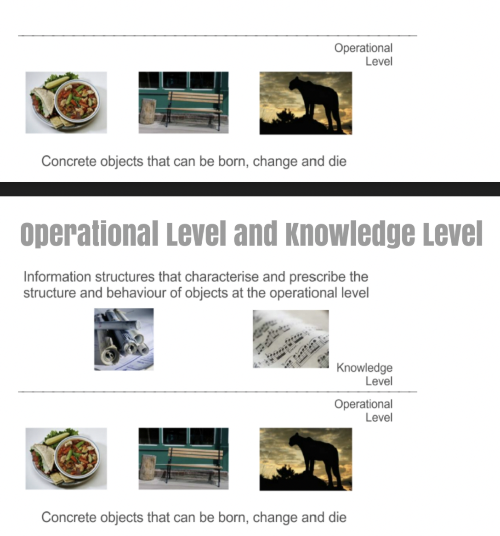

**Operational level and knowledge level**

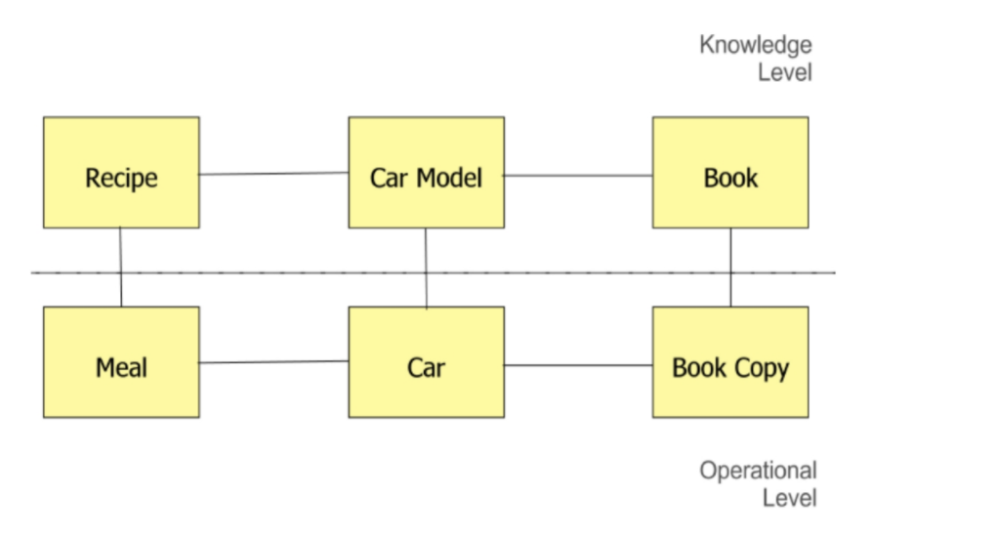

**Value process graphs**

* For each exchange (pair of economic events), introduce a process
* Look at each process from one agent’s perspective (typically the organisation for which the model is constructed)
* For each process. Specify what resources are increased and decreased
* Connect the process according to resources consumed and produced

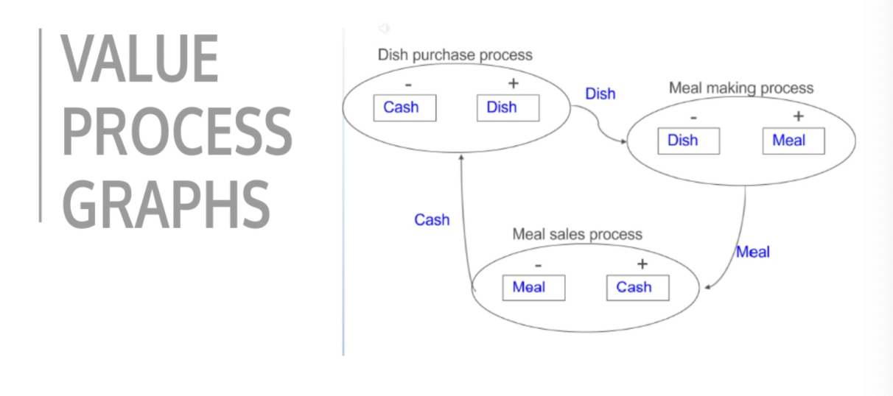

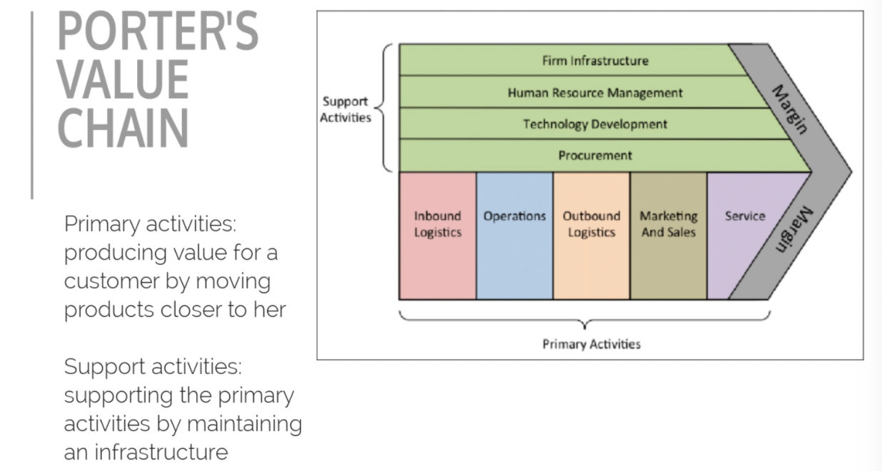

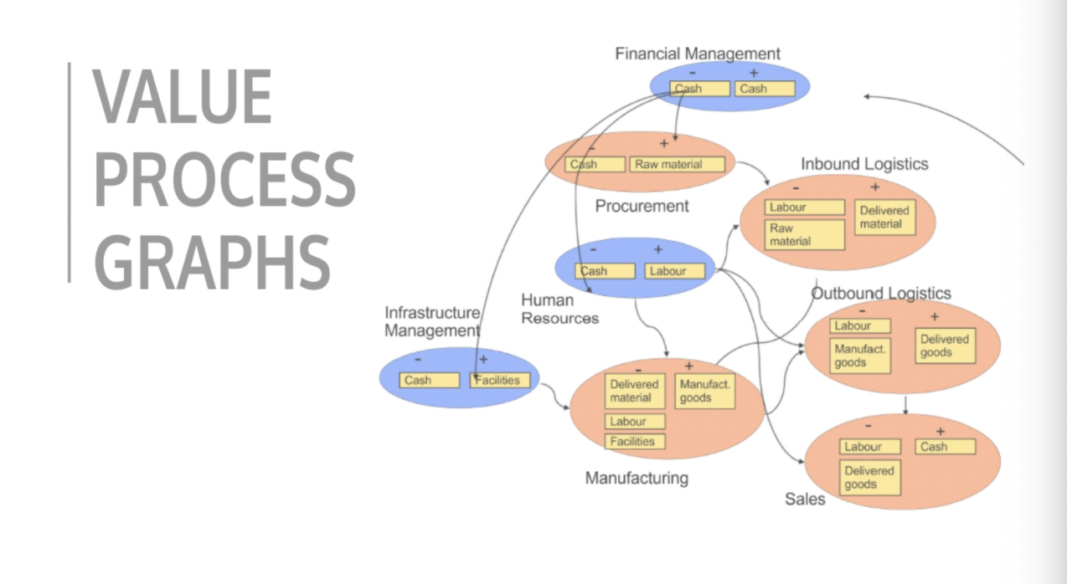

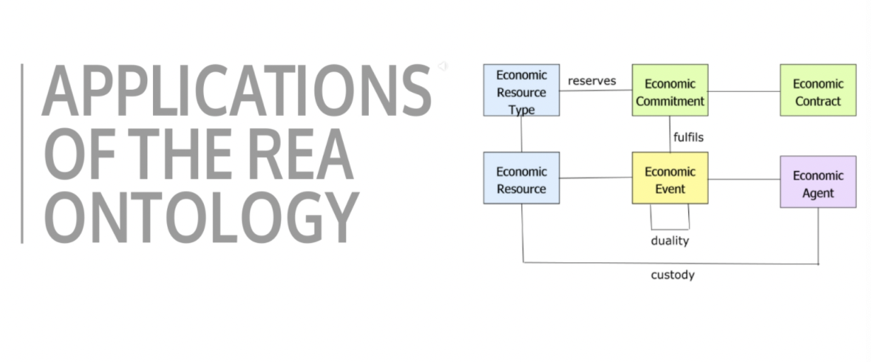

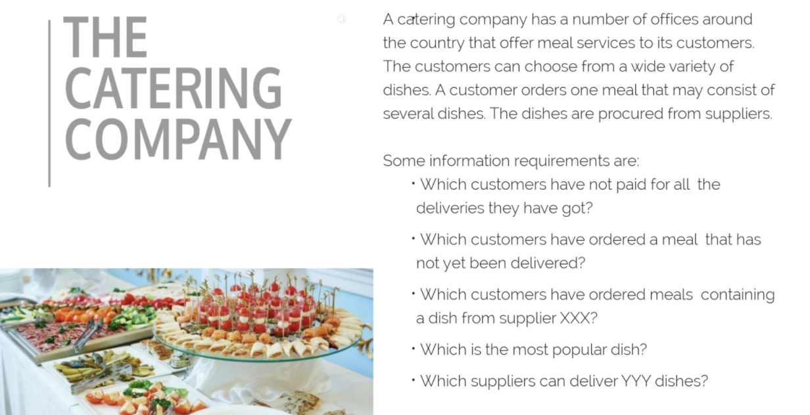

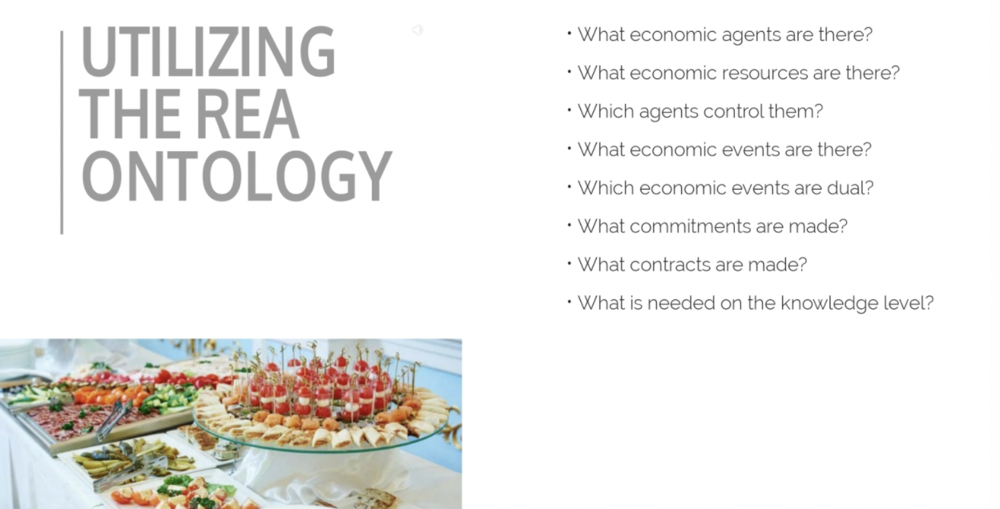

### What economic agents are there?

* Dish supplier
* Office
* Customer

### What economic resources are there?

### 

### 

### 

### What economic events are there?

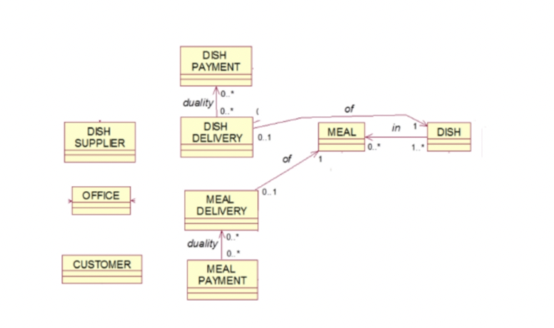

### What economic commitments and contracts are there?

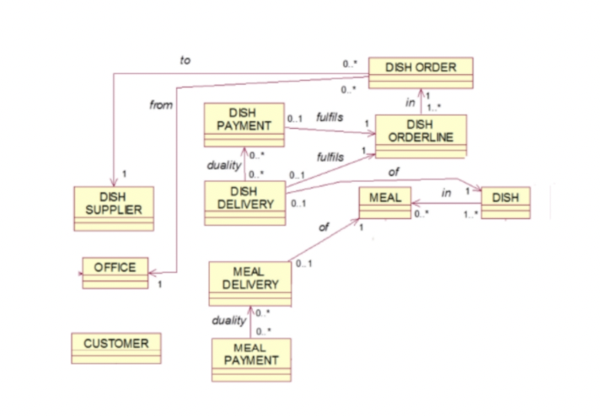

### 

### 

### VDML - value delivery modelling language